29/12/20
THM 415: Finance
Final Exam Answer Sheet
Note to the students:
- Calculations to reach your answers shall be thoroughly shown. Otherwise, questions will NOT be graded.
- You can use a calculator throughout the exam.
1. Why is the yield curve usually upward sloping? (2 Points)
Since there is no reason to believe that the real-risk free rate of interest will change over time, the yield curve is shaped by the inflation premium and the maturity-risk premium. Assuming that inflation won’t change significantly through time and that long-term bonds are subject to higher interest rate fluctuations, it follows that as years to maturity increases, the required rate of return increases also; hence the upward sloping of the yield curve.
2. The following depicts Corporate Bonds Spread Table:
Nejib Corporation is considering issuing bonds that will mature in 20 years with 3.54 % annual coupon rate. The interest will be paid semi-annually. Nejib Corporation is hoping to get a BBB rating on its bonds. However Nejib Corporation is not sure whether the new bonds will receive that very rating.
- What is the price of Nejib Corporation bond? (1 Point)
According to the above Corporate Bonds Spread Table, the yield to maturity on a BBB rated 20-year bonds shall be 2.22 % + 2.59 % = 4.81 %. Therefore, the price of Nejib Corporation bond shall be:
- Bond Price (BBB rating) = - PV (4.81%/2, 20*2, (1000*3.54%)/2, 1000) = $ 838.02.
- What is the price of the bond if it gets a BB+ rating? (1 Point)
According to the above Corporate Bonds Spread Table, the yield to maturity on a BB+ rated 20-year bonds shall be 2.22 % + 2.75 % = 4.97 %. Therefore, the price of Nejib Corporation bond shall be:
- Bond Price (BB+ rating) = - PV (4.97%/2, 20*2, (1000*3.54%)/2, 1000) = $ 820.06.
3. Rıdvan Company’s bonds mature in 37 years time and promise to pay 9.03 % coupon interest quarterly. Suppose you purchase the bonds for $ 1,101.03.
a) What is Rıdvan Company’s promised yield to maturity? (1 Point)
- Promised Yield to Maturity = Rate (37 * 4, (1000 * 9.03 %) / 4, -1101.03, 1000) ≈ 2.04 %.
Since this promised rate is a quarterly rate, the promised yield to maturity shall be 2.04 %*4 = 8.16 %.
b) Assume there is a 63 % probability of default on this bond and if the bond defaults, the bondholders will receive only 71 % of the principal and interest owed. What is the expected yield to maturity on this bond? (2 Points)
In case of default, I will get only 71 % of the principle (i.e. 71 % * 1,000 = $ 710) and 71 % of the payment (i.e. 71 % * (1,000 * 9.03 %) / 4 ≈ $ 16.028). Therefore, Yield to Maturity (Default) = Rate (37 * 4, 16.028, -1101.03, 710) * 4 ≈ 1.38 % * 4 = 5.53 %.
- Expected Yield to Maturity = (37 % * 8.16 %) + (63 % * 5.53 %) = 6.50 %.
4. Diop Corporation is considering three mutual exclusive investments. The projects’ expected net cash flows are as follows:
a) What is the Net Present Value of Projects A, B and C at an appropriate discount rate of 3.74%? (1.50 Point)
- NPV (Project A) = NPV (3.74%, 13450, 17856, 20031, -2523, 5698, -1003, 12500, 14687, 19025, -2021, 5423, 8326, 2547, -1527, -526, 2547, 6598) – 70235 = $ 26,203. 42.
- NPV (Project B) = NPV (3.74%, 8542, 9015, 6327, -1453, 8007, 3415, -6528, 7403, 9403, 7375, 6005, 7912) – 32635 = $ 19,230.05.
- NPV (Project C) = NPV (3.74%, -2020, 5613, 7613, 4003, -2453, 6578, 8578, 9945) – 21899 = $ 8,927.83.
- What is the Equivalent Annual Cost of Projects A, B and C? (1.50 Point)
- EAC (Project A) = PMT (3.74%, 17,-26203.42, 0) = $ 2,110.68.
- EAC (Project B) = PMT (3.74%, 12, -19230.05, 0) = $ 2,018.21.
- EAC (Project C) = PMT (3.74%, 8, -8927.83, 0) = $ 1,311.83.
- What are the Payback Periods for Project A, B and C? (1.50 Points)
- Payback Period (Project A) = 7.29 Years.
- Payback Period (Project B) = 5.64 Years.
- Payback Period (Project C) = 6.30 Years.
- What are the MIRR’s for Project A, B and C? (3 Points)
- MIRR (Project A) = IRR (-75834.47, 13450, 17856, 20031, 0, 5698, 0, 12500, 14687, 19025, 0, 5423, 8326, 2547, 0, 0, 2547, 6598) = 9.48 %.
- MIRR (Project B) = IRR (-38937.96, 8542, 9015, 6327, 0, 8007, 3415, 0, 7403, 9403, 7375, 6005, 7912) = 11.52 %.
- MIRR (Project C) = IRR (-25887.76, 0, 5613, 7613, 4003, 0, 6578, 8578, 9945) = 9.96 %.
- Based on MIRR, which project shall be chosen? Why? (1 Point)
Based only on MIRR (there are problems with rankings of the projects if we don’t use NPV though), project B shall be chosen because its MIRR (11.52 %) is at the same time greater than discount rate (3.74 %) and the highest amongst other projects (all modified projects are conventional cash flow patterns).
5. Ufuk Company is considering an independent project. The project’s expected net cash flows are as follows:
a) Calculate project’s IRR. (1 Point)
- IRR (Project) = IRR (-17000, 16000, 16000, 16000, 16000, - 52000) = 6.77 %.
b) Draw the NPV profile for the project starting with a discount rate of 20% and increments of 5 % until you reach a discount rate of 80 %. (3 Points)
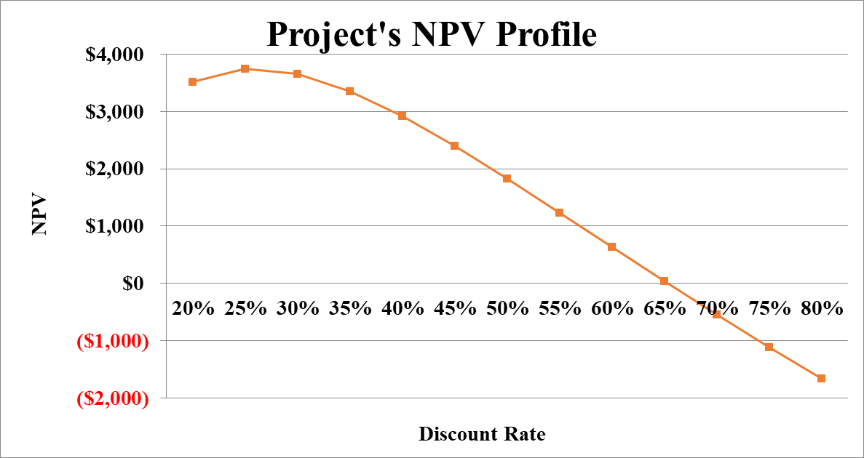
- Referring to the NPV Profile prepared in part b), what is the second IRR of the project? (2 Points)
The second IRR of the project occurs when the discount rate used is 65.36 %.
- What is your decision as far as to accept the project or reject it? (2 Points)
If the appropriate discount rate used to evaluate this very project is between 6.77 % and 65.36 %, accept the project. Otherwise, reject it.
6. Hasic Corporation, a firm in the 27 % marginal tax bracket with a 9.03 % required rate of return or discount rate, is considering a new project. This project involves the introduction of a new product. This project is expected to last 7 years and then, because this is somewhat of a fad product, it will be terminated. Moreover, the following bits of information are pertinent to this very new project:
- Cost of new plant and equipment: $ 5,023,230
- Shipping and installation costs: $ 415,062
Year | Units Sold
1 | 130,000
2 | 152,000
3 | 189,000
4 | 194,000
5 | 115,000
6 | 63,890
7 | 12,602

- Sales price per unit: $ 95 in year 1; expected to increase by 6 % on a yearly basis.
- Variable cost per unit: $ 60 in year1; expected to increase by 4.25 % on a yearly basis.
- Annual fixed costs: $ 4,055,000
- Working capital requirements: There will be an initial working capital requirement of $ 780,000 just to get production started. For each year, the total investment in net working capital will equal 8.53 % of the dollar value of sales for that year. In the final year, all working capital is liquidated at the termination of the project.
- The depreciation method: Use the simple straight line method over 7 years. It is assumed that the plant and equipment will have no salvage value after 7 years.
a) Determine the yearly net free cash flows associated with the project? (5 Points)
- Sketch a timeline for this new project? (0.50 Points)
- Calculate the Profitability Index of the project? (1 Point)
- Profitability Index = NPV (9.03%, 297658, 1230556, 2564780, 3494625, 2064606, 216869, -1526380) / (6218292) = 1.03 times.
- Shall the project be undertaken? Why? Why not? (1 Point)
Since profitability index of the estimated cash flows of the project is greater than 1, Hasic Corporation shall undertake (i.e. accept) the project.
7. Mensah Company is evaluating the purchase of Bernard Company. As a first step, Mensah Company wants to determine the Weighted Average Cost of Capital (WACC) (i.e. the appropriate discount rate to discount future estimated cash flows of Bernard Company). In this regard, Mensah Company determined the following dollar values pertinent to the right hand-side of the balance sheet of Bernard Company:
- What is the weight attributed to each source of capital? (1 Point)
First of all, not all liability and owners’ equity accounts are source of capital. We have to discard accounts payable and accrued expenses. Moreover, we have to look at market values instead of book values. In this regard, the weight attributed to each source of capital is depicted in the following table:
While short debt is entirely coming from a loan obtained from a private bank with a yearly interest rate of 7.23 %, long term debt is entirely coming from an 18-year issued bond (with 14 years to maturity) 8.53 % coupon rate and interest paid on a monthly basis. The bond price is currently traded at $ 935.35. Lastly suppose that marginal tax rate is 28.17 %.
- What is the cost of short-term debt? (1 Point)
- Cost of short-term debt = 7.23 % *(1 – 28.17 %) = 5.19 %.
- What is the cost of long-term debt? (1 Point)
- Yield to maturity = Rate (14*12, (1000*8.53%)/12, - 935.35, 1000) * 12 = 0.78 % * 12 = 9.36 %.
- Cost of long-term debt = 9.36 % * (1 – 28.17 %) = 6.72 %.
- If preferred stocks issued by Bernard Company pays 5.89 % annual dividend and those very preferred stocks are traded currently at $ 817.09, what is the cost of preferred stock? (1 Point)
- Preferred stock dividend = 1,000 * 5.89 % = $ 58.90.
- Cost of preferred stock = (58.90 / 817.09) * 100 = 7.21 %.
Suppose that Bernard Company’s common stockholders have received dividends (pertaining to last year) of $ 6.25 per share and that very company’s common stocks are traded currently at $ 903.03 per share. Lastly, Bernard Company has paid the following dividends during the last 9 years:
- What is the cost of common stock? (1 Point)
Since geometric average takes into account the effect of compounding, it is a better measurement of the common stock growth rate.
- Growth Rate = 8.39 %
- Dividend 1 = 6.25 * (1 + 8.39 %) = $ 6.77
- Cost of common stock = (6.77 / 903.03) + 8.39 % = 9.14 %.
- What is the Weighted Average Cost of Capital (WACC) of Bernard Company? (1 Point)
- Suppose Mensah Company is in need of $ 63,750,000 to finalize the acquisition of Bernard Company. Moreover, the amount needed will be financed 36 % through issuance of common stock and the remaining through issuance of bonds. Lastly, the intermediary bank responsible for the financing told that issue costs associated with bonds is 7.03 % while issue costs associated with equity is 9.72 %. What is the floatation cost associated with the acquisition of Bernard Company? (1 Point)
- Floatation cost of issuance of bonds = 7.03 %
- Weight of bonds in financing = 64 %
- Cost of issuance of common stock = 9.72 %
- Wight of common stocks in financing = 36 %
- Weighted average floatation cost = (64 % * 7.03 %) + (36 % * 9.72 %) = 8.00 %.
- Floatation cost associated with acquisition = 63,750,000 / (1 – 8.00 %) = $ 69,292,273.18.
Mensah Company uses Discounted Payback Period as the criterion to decide whether to finalize the purchase or not. Moreover, Mensah Company values 3.50 years as the cutoff period. Finally, the estimated cash flow generated from the purchase of Bernard Company for the next 10 years is depicted as the following:
- Shall the acquisition be finalized? Why? Why not? (Show all necessary calculations) (2 Points)
Since Mensah Company uses discounted payback period to evaluate its projects, we shall calculate the discounted payback period of Bernard Company (bearing in mind that discount rate is 6.94 %):
- Discounted Payback Period (Bernard Company) = 3.90 Years.
→ Since discounted payback period (i.e. 3.90 Years) is greater than cutoff period (i.e. 3.50 years), Mensah Company shall NOT finalize the acquisition of Bernard Company.
Good Luck

